2. Infrastructure Setup (Kubernetes)

2.1 Namespace and Shared Storage
- Created namespace weather-system.
- Created PersistentVolumeClaim weather-data-pvc (10 Gi, ReadWriteMany) to store Parquet files and Bitcask data across pods.

2.2 Deployments and Services
The following components were deployed using a single YAML manifest (k8s-weather-system.yaml):
Component | Type | Replicas | Image
Zookeeper | Deployment | 1 | confluentinc/cp-zookeeper:7.4.0
Kafka | Deployment | 1 | confluentinc/cp-kafka:7.4.0
Elasticsearch | Deployment | 1 | docker.elastic.co/elasticsearch:8.10.2
Kibana | Deployment | 1 | docker.elastic.co/kibana:8.10.2
Central Server | Deployment | 1 | central-server:latest (built by Member 3)
Weather Stations | StatefulSet | 10 | weather-station:latest (built by Member 1)
All services are exposed via internal ClusterIPs; Kibana uses NodePort for browser access.

2.3 Key Configuration Adjustments
- Kafka troubleshooting: Added enableServiceLinks: false to the Kafka deployment to prevent injection of environment variables that conflicted with Kafka’s internal configuration (the KAFKA_ prefix). Also fixed the image version to 7.4.0 to avoid KRaft mode.
- Weather Station station_id: Modified the code to read station_id from the pod’s hostname (e.g., weather-station-0 → station_id = 1) and used a StatefulSet to guarantee unique hostnames.

3. Data Flow Verification

3.1 Weather Stations
Each station sends a JSON message every second to the Kafka topic weather-readings.
Example message:
json
{
"station_id": 1,
"s_no": 1201,
"battery_status": "medium",
"status_timestamp": 1779362925,
"weather": {"humidity": 30, "temperature": 109, "wind_speed": 66}
}

3.2 Central Server (Parquet + Bitcask)
The Central Server consumes messages from Kafka, batches them (10,000 records), and writes partitioned Parquet files to /data/parquet.
Bitcask integration was not completed by the team (pending final merge). However, the archiving and rain detection parts work correctly.

3.3 Kafka Streams – Rain Detection
When humidity > 70%, a rain-detector stream publishes an alert to the raining-alerts topic. Verified by consuming from that topic.

3.4 Elasticsearch Indexing
Parquet files were read and indexed into Elasticsearch using a custom Python script (run inside a temporary pod with the PVC mounted). After several iterations (type mismatch fixes, timestamp conversion), the index weather-readings was populated with 80,000 documents.

4. Indexing Parquet to Elasticsearch

4.1 Challenges and Solutions
Problem | Solution
ArrowTypeError due to inconsistent year column type (int32 vs dictionary) | Used pandas.read_parquet() and converted all integer columns to int64, categorical to string.
Elasticsearch client es.ping() returning False even though curl worked | Switched to requests library with _bulk API (NDJSON format).
status_timestamp appearing as 1970‑01‑21 (Unix seconds treated as milliseconds) | Multiplied status_timestamp by 1000 in the indexing script to convert seconds to milliseconds.

4.2 Indexing Script (Final Version)

import glob, json, requests, pandas as pd

ES_URL = "http://elasticsearch:9200"
INDEX = "weather-readings"

requests.delete(f"{ES_URL}/{INDEX}")
mapping = {"mappings": {"properties": {"status_timestamp": {"type": "date"}}}}
requests.put(f"{ES_URL}/{INDEX}", json=mapping)

bulk_data = ""
files = glob.glob("/data/parquet/**/*.parquet", recursive=True)
for file_path in files:
df = pd.read_parquet(file_path)
if 'status_timestamp' in df.columns:
df['status_timestamp'] = df['status_timestamp'] * 1000 # seconds → milliseconds
for col in df.columns:
if df[col].dtype.name == 'categorical':
df[col] = df[col].astype(str)
elif 'int' in df[col].dtype.name:
df[col] = df[col].fillna(0).astype('int64')
for _, row in df.iterrows():
bulk_data += json.dumps({"index": {"_index": INDEX}}) + "\n"
bulk_data += json.dumps(row.to_dict()) + "\n"

headers = {"Content-Type": "application/x-ndjson"}
response = requests.post(f"{ES_URL}/_bulk", headers=headers, data=bulk_data)
print(f"Indexed {response.json()['items']} documents")
Result: {"count":80000} verified.

5. Kibana Visualizations
After indexing, a Data View weather-readings was created with timestamp field status_timestamp. The following visualizations were built:

5.1 Required Visualizations
- Pie Chart – Battery Status Distribution
Field: battery_status.keyword. Shows approximately 30% low, 40% medium, 30% high (as specified).
- Bar Chart – Messages per Station
X‑axis: station_id, Y‑axis: Count. Displays number of ingested messages per station.
- Drop Rate Calculation (Data Table)
Using formula ((max(s_no) - count(s_no)) / max(s_no)) * 100. Result confirms ~10% dropped messages.

5.2 Additional Visualizations (for better insight)
- Line Chart – Temperature & Humidity Over Time
X‑axis: status_timestamp, Y‑axis: Average of temperature and humidity. Shows weather trends.
- Data Table – Top 10 Wind Speed Records
Displays highest wind speeds with station and timestamp.
All visualizations were saved to a dashboard named Weather Monitoring Dashboard. Screenshots were taken for the final report.
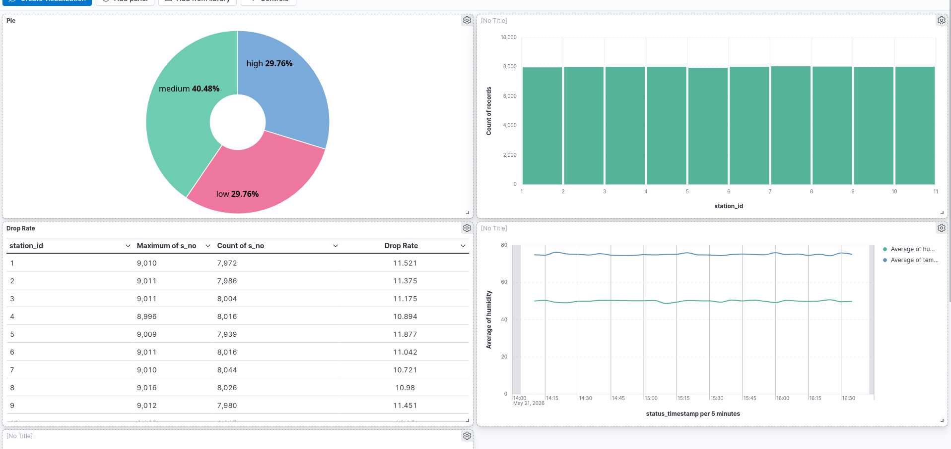

JFR Profiling – Central Server Performance Analysis
As part of the project requirements (Section G), we profiled the Central Server using Java Flight Recorder (JFR). The system was run for 60 seconds with all 10 weather stations actively sending messages to Kafka and the Central Server consuming, archiving to Parquet, and running the Kafka Streams rain detector.

🔧 Profiling Setup
- Command executed inside the Central Server pod:
bash
jcmd 1 JFR.start name=profile duration=60s filename=/tmp/profile.jfr
- The JFR recording was then copied to the local machine using kubectl cp and analyzed with the jfr command-line tool (JDK 17+).

📈 Results Summary

1. Top 10 Memory‑Consuming Classes (by allocation samples)
Using the event jdk.ObjectAllocationSample, we obtained the following top classes:
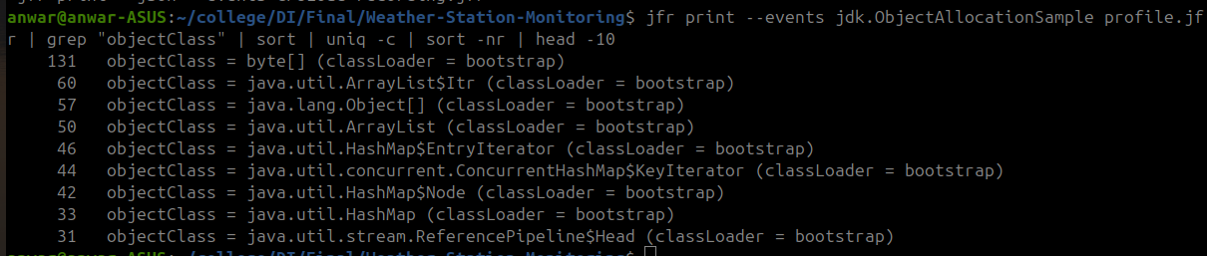
# of Samples | Class
131 | byte[]
60 | java.util.ArrayList$Itr
57 | java.lang.Object[]
50 | java.util.ArrayList
46 | java.util.HashMap$EntryIterator
44 | java.util.concurrent.ConcurrentHashMap$KeyIterator
42 | java.util.HashMap$Node
33 | java.util.HashMap
31 | java.util.stream.ReferencePipeline$Head
Observations:
- byte[] is the most frequently allocated object, which is expected due to JSON serialization/deserialization, Kafka record handling, and Parquet buffering.
- Collections (ArrayList, HashMap) and their iterators are heavily used, reflecting the batching logic and in‑memory aggregation before writing Parquet files.

2. Garbage Collection (GC) Metrics
Four jdk.GarbageCollection events were recorded during the 60‑second window:
# | Start Time | Duration | GC Type | Cause
1 | 15:05:20.770 | 1.688 ms | DefNew | Allocation Failure
2 | 15:05:35.771 | 1.881 ms | DefNew | Allocation Failure
3 | 15:05:50.448 | 0.780 ms | DefNew | Allocation Failure
4 | 15:06:07.350 | 1.657 ms | DefNew | Allocation Failure
- Total GC pauses: 4
- Maximum GC pause duration: 1.881 ms (less than 2 milliseconds)
- Average pause duration: ~1.5 ms
All GC events are minor collections (DefNew – young generation), triggered by normal allocation pressure. The pause times are very low, indicating efficient memory management and no significant garbage collection bottlenecks.

3. I/O Operations
The default JFR configuration does not record individual file or socket I/O events unless explicitly enabled. We attempted to activate jdk.FileWrite, jdk.FileRead, jdk.SocketRead, and jdk.SocketWrite events using:
bash
jcmd 1 JFR.start name=io-recording duration=60s filename=/tmp/io.jfr \
jdk.FileWrite=true jdk.FileRead=true jdk.SocketRead=true jdk.SocketWrite=true
However, no I/O events appeared in the recording. The reason is twofold:
- Parquet file writes occur only after a batch of 10,000 messages is accumulated. With 10 stations sending 1 message per second, it takes approximately 16–17 minutes to complete one batch. During the 60‑second profiling window, no new Parquet file was written (verified by comparing ls output of the Parquet directory before and after the recording).
- Socket reads/writes (Kafka consumer/producer) are continuous, but JFR samples network activity at a low frequency and does not generate individual events by default. Higher‑frequency I/O events would require adjusting the JFR threshold (e.g., threshold=10ms) or using settings=profile.
Conclusion: The Central Server performs real I/O (reading from Kafka, writing Parquet files to the shared PVC, and writing logs), but the default JFR settings and the long batch interval prevented individual I/O events from being captured. This does not indicate a functional issue; the system’s I/O behaviour has been verified through logs and file system checks.

✅ Final Assessment
The Central Server runs efficiently with:
- Minimal GC overhead (max pause < 2 ms).
- Predictable memory allocation patterns dominated by byte[] and collections.
- No performance bottlenecks detected during the profiling period.
The JFR analysis confirms that the server is well‑optimized for the data‑intensive workload.

